IYCF-E Fact Sheet For Mothers

(Note by taking out headings/logos this can be made into a 2 sided handout): Information on Feeding Your Baby

Keeping your young child safe after the conflict:

The conflict has made the environment particularly hazardous for small children. The destruction of homes has made the surroundings very dusty and dirty. The normal house with a cooking stove and washing facilities is no-longer available for many people. Water is scarce and can be of bad quality, sanitation has also been affected. People either have very little gas to heat things or none at all, which means that it is hard to heat food sufficiently or boil water. Food storage facilities are not as good. In these circumstances there is a high risk that small children and babies can get sick especially with vomiting or diarrhoea.
Making up milk and milk products such as infant and young child milk is particularly dangerous in this environment. The water needs to be boiled and cooled, but it can easily become contaminated then the milk will also be contaminated, also the bottles and teats need to be sterilised before each feed and this is very difficult in these circumstances, hence the baby may well get sick with diarrhoea or vomiting.

To help keep your baby or young child safe it is important that:
- All new born babies start to breast-feed within one hour after delivery (including the first milk called colostrums). The baby should only get breastmilk, no infant formula or water should be given to newborn babies. The mothers supply of breastmilk is sufficient
- Breastfeed infant exclusively for six months. This means that the baby receives nothing else except breast-milk. The infant should not receive water, juices, porridge or any other foods. Feed the baby frequently, and allow the baby to feed until satisfied. The baby may pause from feeding but continue to offer the breast as it is important that the baby takes the “hind milk”, which comes later during a feed, as this milk is high in fat content, full of energy, which helps the infant gain weight and grow.
- From six months introduce complementary foods such as porridge, fruit, small amounts of meat/fish and vegetables. You can add a little oil to food to increase the energy content. Complementary foods should be very soft, semi-liquid especially for the younger children.
- Continue breastfeeding up to two years or beyond.
Benefits of Breast-milk / How to breastfeed:
- The first milk after delivery called “colostrum” is very important. It is rich in factors that protect the child from infection. Therefore it is important to get the baby to breastfeed as soon as possible after delivery, ideally within an hour
- Breastfeed on demand. This means breastfeed as often as the baby demands milk.
- Breast-feed exclusively which means give only breastmilk. By introducing other foods too early the infant is not as hungry for breastmilk and therefore does not demand as much. This in turn means the mothers breastmilk supply reduces. A small infant’s stomach is not developed enough to take foods such as porridge, it can cause diarrhoea in young infants.
Breastmilk is produced on a demand/supply basis. The more the infant demands food the more milk the mother will supply. The suckling action of the baby on the breast stimulates breastmilk production.
- Breast-milk is safe as it comes directly from the mothers breast
- Breast-milk is like a special ‘medicine’ as it contains properties to protect the child against illnesses (baby milk (formula) does not have this)
- It is readily available, therefore the mother does not need to spend time boiling water, or preparing other foods for her infant
- No cost: as the mother produces the milk herself therefore it is free of charge
- Helps in mother child bonding and contains all the requirements needed for the best development of the child. (Baby milk (formula) can NEVER be made as good as breast-milk)

Complementary foods:
Start complementary food at six months increasing the consistency gradually as the infant gets older. Initially the food should be pureed, mashed or semi-solid. It is important that the mother continues to breast-feed frequently especially for the younger infants. Do not give any other milk product, breastmilk is the best and safest.

Frequently Asked Questions or Thoughts:
- Is my baby getting enough breastmilk?
A MOTHER DOES PRODUCE ENOUGH MILK TO FEED HER BABY
If the baby is hungry and feeding frequently, does not look visibly thin and is producing pale urine about 6 times a day they are getting enough milk. A baby should be gaining weight slowly and steadily, exclusively breastfed babies grow at a slower rate than formula fed babies, but this is healthier for the baby. A baby should gain about 500gms every month. Remember: milk production works on a supply-and-demand basis: as long as the baby is put to the breast, is well attached and is allowed to suckle as often and as long as he/she demands, supply will meet all the baby’s needs.
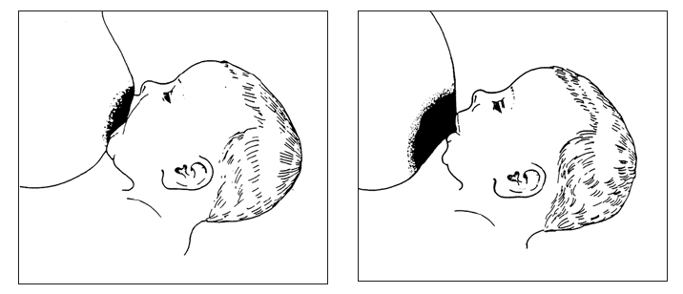
Good Attachment
- More areola visible above the mouth
- Mouth wide open
- Lower lip turned out
- Chin touching or nearly touching the breast

Poor Attachment

2. Will stress make my milk dry up?
NO, STRESS DOES NOT NECESSARILY PREVENT A MOTHER FROM PRODUCING MILK
While extreme stress or fear may cause milk to momentarily stop flowing, this response is temporary and can be overcome with stress reduction and counselling. Breastfeeding produces hormones that reduce tension, calm the mother and the baby and create a loving bond.
3. I’m not getting enough food / the type of food I am eating is not good so I am not producing milk.
OTHER THAN IN SEVERE CASES, MALNOURISHED MOTHERS CAN BREASTFEED.
A woman has plenty stores in her body to produce good quality and quantity of breast-milk even if her diet has been poor for some time. Quantity of breast-milk only reduces when a small baby is receiving other foods and does not demand as much breastmilk. Even moderately malnourished women (very thin) can produce enough breastmilk. Continue to breastfeed the infant <6 months exclusively and try to improve your diet.
4. My baby has diarrhea should I stop breastfeeding?
NO, DO NOT STOP FEEDING IF THE BABY HAS DIARRHOEA.
Breastmilk contains water, it also supplies important minerals and vitamins to prevent dehydration, as well as proteins to help strengthen the immune system of the baby. Increase the frequency of breastfeeding. (Note: If severe diarrhoea, oral rehydration therapy, given by cup, using SAFE water may be required.)
5. It is too late now my milk is very little / my milk has stopped, so I have to give my baby formula.
IF A MOTHER STOPS BREASTFEEDING SHE CAN USUALLY RESTART AGAIN.
This is particularly true when breastfeeding has stopped because of stress or because bottle feeding was started or because the use of substitutes has reduced the milk production. If the child is still breastfeeding sometimes, breastmilk supply should increase in a few days. If the child has stopped breastfeeding completely it may take 1-2 weeks or more before much breastmilk is produced.
- Be motivated. Remember breastfeeding is important and formula feeding can be dangerous, especially in emergency situations when formula may not always be available, there is the risk of disease, and poor access to water and poor sanitation make feeding with formula very risky.
- Get support from your family, friends and health workers.
- Keep your child with you as much as possible, have frequent skin-to-skin contact and if possible sleep together, so that breastfeeding is easier during the night, but this is up to the mother.
- Encourage the baby to suckle as often as possible, whenever he/she appears interested. The baby should suckle ever 1-2 hours, at least 8-12 times within a 24 hour period. The baby should suckle from both breasts. In particular encourage the baby to breastfeed at night. (You can also express milk to increase milk production between feeds)
- While waiting for the milk to come in you need to feed the baby other milks. These feeds should preferably be fed with a cup AFTER suckling the breast. If the baby will not suckle at the breast the baby can be encouraged by dropping baby milk onto the breast while he/she is suckling, or a supplementer can be used (ask at your clinic/health worker).
- Always breastfeed first and then provide formula. The amount of formula that is given to the child should be reduced over a period of time.

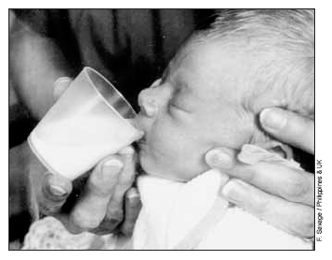
Reducing the risks associated with artificial feeding
Breastfeeding is important, however, when it is not practiced or formula is given along with breastmilk then it is important that formula feeding should be made as safe as possible:
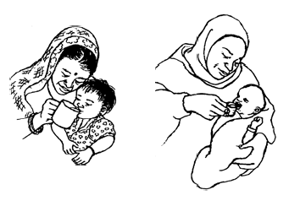
-Bottles and teats (and beakers with a spout) should not be used in an emergency situation as they are very difficult to sterilise, which then increases the risk of the baby getting sick with diarrhea and vomiting, which can lead to a child’s death. Easily cleaned cups should be used for giving the breastmilk substitute to the child. (To clean cups: Wash and scrub them in hot soapy water each time it is used. If possible, dip the cup into boiling water or pour boiling water over it just before use.)
How to cup feed: Hold the baby upright, or semi-upright in your lap. Use a small cup. Tip the cup so that the milk just reaches the babies lips, the cup should rest lightly on the baby’s lower lip and the edges of the cup should touch the outer part of the baby’s upper lip. A baby will suck or sip the milk spilling some of it. Do NOT pour the milk into the baby’s mouth, just let the baby take it. When the baby has had enough the baby will close their mouth and refuse to take anymore. If the baby has not taken enough they may take more next time or it may be necessary to increase the frequency of feeding. Measure the baby’s intake over a 24-hour period rather than at each feed.
- For more information contact: Health workers and mothers wanting free breastfeeding advice can call the Lebanese Association for Early Childhood Development. Iman El-Zei El-Salah on 03824100 or 01646729
- Produced by Save the Children. alimaclaine@btinternet.com Please feel free to copy and distribute widely.

[Acknowledgements: Save the Children would like to acknowledge the support of the TOPS Micro Grant Program which was made possible by the generous support and contribution of the American people through the United States Agency for International Development (USAID). The original version of this document, and the other IYCF-E Toolkit documents, can be found at https://resourcecentre.savethechildren.net/iycf-e]

